<page_start no = 1>
<sol_start id=1>
1. (3) Concave mirror
<sol_end>

<sol_start id=2>
2. u = 10 cm
m = –3
v = 30 cm
r = 7.5 cm
(3) 30 cm, 7.5 cm
<sol_end>

<sol_start id=3>
3. (4) Both 2 and 3
<sol_end>

<sol_start id=4>
<sub_id = 1>
4. (i) Focus :- After reflection where the points converge I a concave mirror and appear to diverge from in a convex mirror to form an image is called the focus or principal focus as it lies on the principal axis, It is denoted by f.
<sub_id end>
<sub_id = 2>
(ii) Centre of curvature :- The centre of curvature is the centre of the sphere of which the spherical mirror is a part.
It is denoted by ‘c’.
<sub_id end>
<sol_end>
<page_end>

<page_start no = 2>
<sol_start id=5>
5. 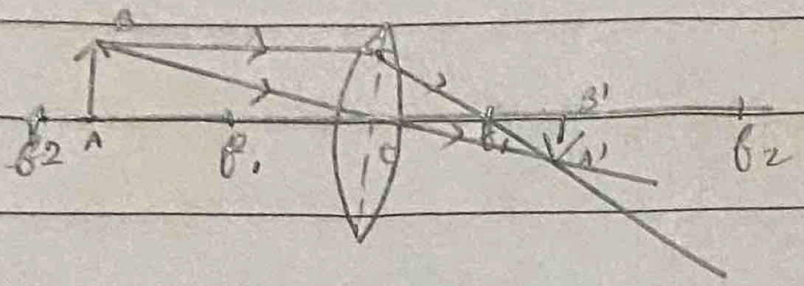
v = +18
18 rs = –u
u = –90
r = 15 cm
The nature of the lens is a convex lens, converging lens.
<sol_end>

<sol_start id=6>
<sub_id = 1>
6. (i) h_{o} = 7 cm
u = –27 cm
f = –18 cm
By mirror formula,
v = –54 cm
h_{i} = –14
m = –2
∴ The image is magnified and it’s a real image and the screen should be placed 54 cm infront of the mirror to get the image.
<sub_id end>
<sub_id = 2>
(ii) R = 5 cm
u = –20 cm
f =
v = 2.22 cm
= 0.11
∴ The image is shoter than the object, the image will be smaller, and the nature of image is virtual, upright and diminished.
<sub_id end>
<sub_id = 3>
(iii) The mirror used by the dentist is concave mirror. This is because concave mirror forms a virtual, erect and enlarged image when the object is placed within focus.
<sub_id end>
<sol_end>
<page_end>

